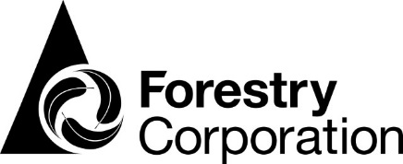
Planner/Senior Planner
- Permanent Position
- Working on the South Coast of NSW from the Batemans Bay office
- Competitive Salary
- Flexible work arrangements
We pride ourselves on being the largest manager of commercial plantation & native forests in New South Wales. We manage renewable timber production, environmental sustainability & recreation across more than two million hectares of NSW State forests. You can discover more about Forestry Corporation & the work we do by visiting www.forestrycorporation.nsw.com.au
About the Position:
Working with the Planning team the Planner/Senior Planner produces operational harvest and haulage plans for timber harvesting in native forests around Batemans Bay, Eden and Tumbarumba. The position requires you to work autonomously to produce plans that are safe, accurate and effective, to ensure the corporation meets its supply commitments to customers and contractors. The position also contributes to the burning program, assists with ecology surveys and provides planning advice to staff. As the role involves working in Batemans Bay, Eden and Tumbarumba, some travel will be expected. The successful candidate will be required to undertake active frontline firefighting duties and be available for afterhours fire standby on a rostered basis.
About You:
The ideal candidate would possess the following:
- Bachelor’s degree in forestry, environment, science, natural resources or related field; or a forestry diploma and relevant experience.
- Experience in operational planning, native forest silviculture and ecology.
- Knowledge, skills and experience in the use GIS and other technologies.
- Understanding of relevant legislation, regulations and best practice methodologies.
- Ability to plan and prioritise work, meet standards and deadlines.
- Good interpersonal, oral and written communication skills, ability to work as a team.
- Capacity and willingness to undertake fire and fuel management duties, fire-fighting, and extensive travel (mainly driving), work extended hours, and to maintain sufficient fitness for the job.
How to apply: Applicants should email their applications to jobapplications@fcnsw.com.au. Please provide an updated CV and a cover letter outlining what you would bring to the role.
Closing Date: Applications must be received by 24th August 2018.
For more information, please contact Shane Clohesy on 0437 737 605.
Note: The successful applicant will be required to satisfactorily complete a Drug and Alcohol screening, a Medical Assessment and a Fire Task Based Assessment (TBA) at a standard of at least a Category 2 Field Test.

